|  |  |
| --- | --- |
| Balcomb LetHead Logo 2.jpg |  |
|  | Scott Grosscup  Direct Dial (970) 928-3468  Receptionist (970) 945-6546  sgrosscup@balcombgreen.com |
|  |  |

September 22, 2016

*Via U.S. Mail*

|  |  |  |  |  |
| --- | --- | --- | --- | --- |
| Kelly Sheridan  P.O. Box 865  Meeker, CO 81641 |  | Benjamin J. Rogers  P.O. Box 1083  Meeker, CO 81641 |  | Walter N. Proctor  P.O. Box 642  Meeker, CO 81641 |
| David Smith, Jr.  P.O. Box 359  Meeker, CO 81641 |  | Kai M. Turner  45840 Highway 13  Meeker, CO 81641 |  | Shawn Welder  P.O. Box 2318  Meeker, Co 81641 |
| Paul Neilson  P.O. Box 656  Meeker, CO 81641 |  | Bailey Franklin  P.O. Box. 1236  Meeker, CO 81641 |  |  |

**Re: September 27, 2016 Meeting**

Dear Directors:

Enclosed are meeting materials for the next meeting of the Yellow Jacket Water Conservancy District, to be held Tuesday September 27, 2016 from 2:00 to 4:00 pm. The meeting will be held at the Fairfield Center, 200 Main Street, in Meeker, CO.

Enclosed is a preliminary draft from Applegate Group that identifies additional storage sites and evaluates need and demands for water within the White River Basin. It also addresses possible storage locations for the District’s remaining water rights portfolio and the pros and cons of such locations. This report is still and draft form, and there are a number of typographical errors and formatting issues that will need to be addressed. I believe Craig Ullmann will be at the meeting to discuss his findings.

Additionally, we will have a discussion about the 2017 budget and future of the District. As you are aware, the District does have a limited budget. It is primarily funded from property taxes. An increase in property taxes requires an affirmative vote from the electorate. Also attached is a letter from Walt Proctor describing some of the hurdles with the budget and near term and long term demands. Without some mechanism to increase the District’s budget, its long-term health and viability is questionable.

See you next week.

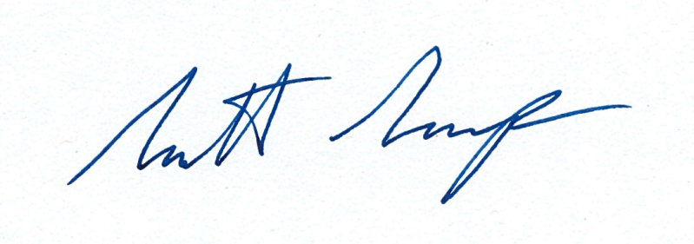Very truly yours,

By:__________________________

Scott Grosscup