Scott Grosscup

Office (970) 945-6546

Direct (970) 928-3468

sgrosscup@balcombgreen.com

Novmeber 30, 2018

|  |  |  |  |  |
| --- | --- | --- | --- | --- |
| Kelly Sheridan  843 County Road 6  Meeker, CO 81641 |  | Benjamin J. Rogers  P.O. Box 1083  Meeker, CO 81641 |  | Walter N. Proctor  P.O. Box 642  Meeker, CO 81641 |
| David Smith, Jr.  P.O. Box 359  Meeker, CO 81641 |  | Kai M. Turner  45840 Highway 13  Meeker, CO 81641 |  | Shawn Welder  P.O. Box 2318  Meeker, Co 81641 |
| Paul Neilson  P.O. Box 656  Meeker, CO 81641 |  | Bailey Franklin  P.O. Box. 1236  Meeker, CO 81641 |  |  |

**Re: Board Meeting – December 6, 2018**

Dear Directors:

Enclosed are materials for the Board meeting for the Yellow Jacket Water Conservancy District for Thursday, December 6, 2018 at 2:00 p.m. The meeting will be held at the Meeker Public Library and will be open to the public.

The meeting will include a discussion of the 2019 budget. The budget is similar to past years. It consinders funding of additional engineering expenses for support of the District’s study in how to best use its conditional water rights. This study could include additional study of Lake Avery or of the alternate storage locations.

It also includes additional legal expense in prosecuting the first of several applications to change the places of storage for certain water rights. This change case would be to move the Sawmill Mountain Reservoir rights to Lake Avery. Included is a letter of support from Colorado Parks and Wildlife.

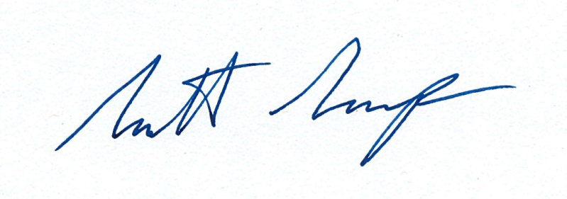Sincerely,

Scott Grosscup