**Summary of Past Studies - Board Mtg 2/13/2020**

# Remaining YJWCD Water Rights:

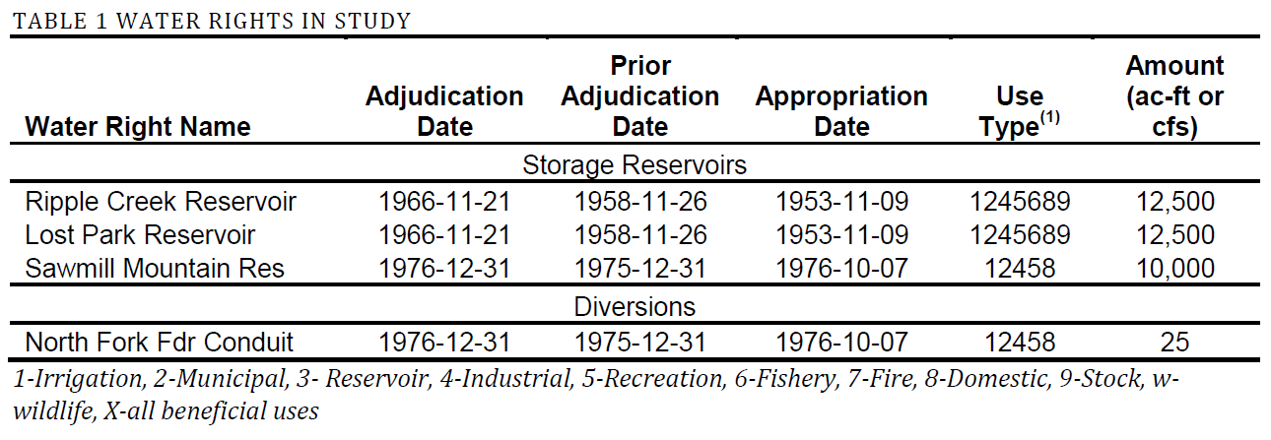

Primary drivers for a future call:

* Taylor Draw Power Conduit – Junior to Ripple Creek and Lost Park
* Instream flow from Confluence of N. and S. Fork to Piceance Ck – junior to all remaining YJWCD water rights, however stipulations state that no diversions by YJWCD will be allowed to deplete the instream flow water right.

# From 2016 Study:

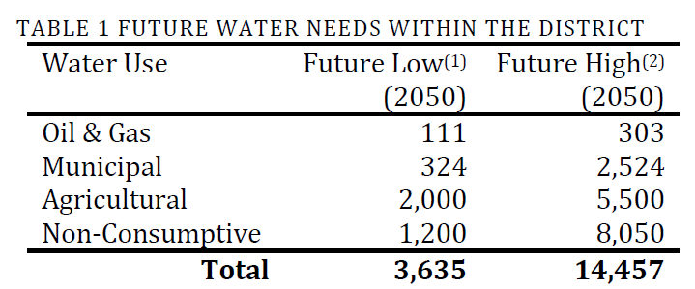

# From April 2017 Memo:

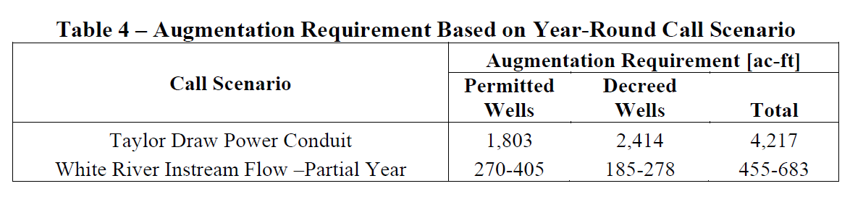

**Reservoir Summary**

* Lake Avery Expansion
  + Sawmill water right which is junior to Taylor Draw.
  + Extreme drought years water right could be out of priority all year long but not in back to back years.
    - Carry over storage required for about 1 year to achieve firm yield
  + Cannot store water on Livingston Property
  + Up to 4,350 acre feet based on current data
  + $2,000-$9,000 per acre-ft
* Off Channel Reservoirs – Oak Ridge Park Ditch
  + Ripple Creek/Lost Park water rights, senior to Taylor Draw
  + Available for diversion during all water years
  + Cannot augment depletions or streamflows above Oak Ridge Park Ditch
  + Pumping required on most options – annual operating cost
  + $3,000 to $5,000 per acre-ft
  + Possible endangered species issues identified in earlier study – may not be an issue in the future.
* Dowstream Reservoir Location – Tom Little Gulch
  + Ripple Creek/Lost Park water rights, senior to Taylor Draw
  + Available for diversion during all water years
  + Cannot augment depletions or streamflows above site
  + Pumping required
  + $1,500 to $2,200 per acre-ft for 17,000 acre-ft reservoir option
    - Would increase for a smaller reservoir